Smart Street Light

Traditional street lights operate on a fixed schedule, consuming significant energy and potentially casting unnecessary light pollution. Smart street lights, on the other hand, represent a technological leap forward in urban lighting infrastructure.

This abstract introduces the concept of smart street lights, highlighting their key features and potential benefits.

# Key Features:

* **Sensors:** Equipped with light level sensors, motion detectors, or even cameras, smart street lights can adapt their brightness or turn on/off based on real-time conditions.
* **Communication Networks:** Utilizing wireless protocols like Bluetooth or mesh networks, smart lights connect to a central management system for monitoring and control.
* **LED Technology:** Smart lights typically employ energy-efficient LED bulbs, further reducing energy consumption.

## Potential Benefits:

* **Energy Savings:** By automatically adjusting light levels, smart street lights can significantly reduce energy consumption compared to traditional systems.
* **Reduced Light Pollution:** By minimizing unnecessary illumination, smart lights can

mitigate light pollution, improving night time visibility of stars and aiding nocturnal wildlife.

* **Enhanced Public Safety:** Improved lighting in areas with detected movement can deter crime and increase pedestrian safety.
* **Data Collection:** Sensors can gather data on traffic patterns, aiding in urban planning and resource allocation.

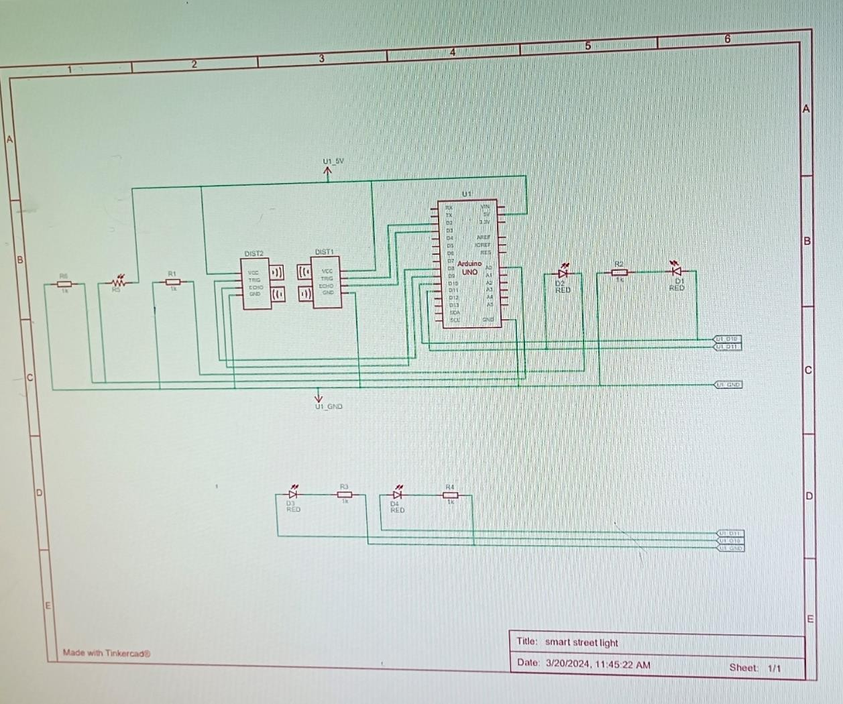

Fig: Schematic view of Smart Street Light

# Applications:

Smart street lights have applications in various urban environments, including:

* City streets and highways
* Parks and pedestrian walkways
* Public parking lots

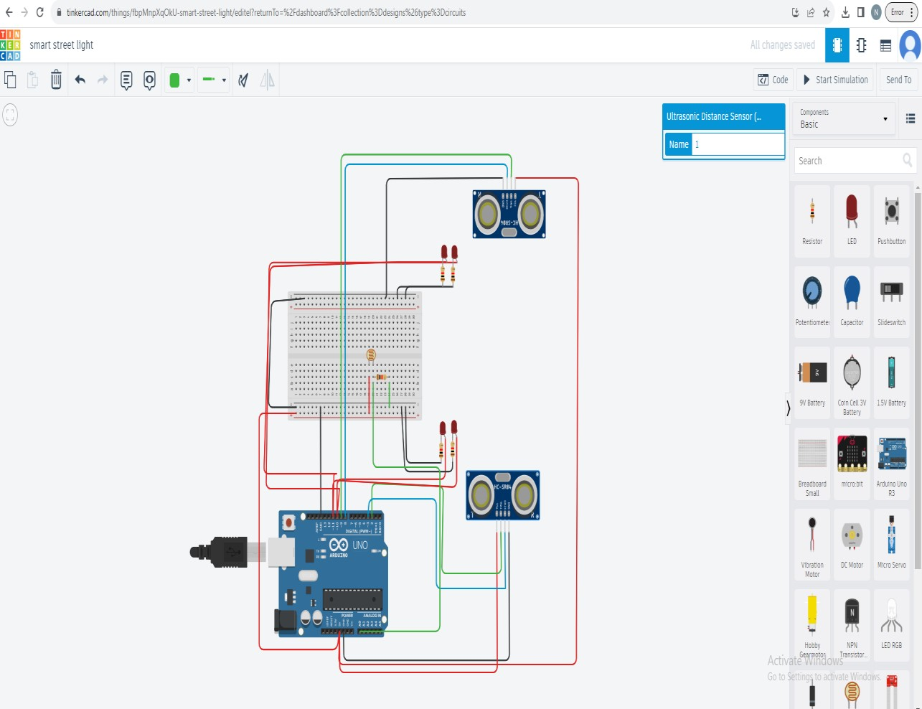

**PROGRAM:**

// C++ code

//

int trigger_pin1 = 2; int echo_pin1 = 3; int trigger_pin2 = 9; int echo_pin2 = 8; int led1= 10;

int led2= 11; int time;

int distance; int ldr;

void setup()

{

Serial.begin (9600);

pinMode (trigger_pin1, OUTPUT); pinMode (echo_pin1, INPUT); pinMode (trigger_pin2, OUTPUT); pinMode (echo_pin2, INPUT); pinMode (led1, OUTPUT); pinMode (led2, OUTPUT);

}

void loop()

{

ldr=analogRead(A0); Serial.print(ldr);

digitalWrite (trigger_pin1, HIGH); delayMicroseconds (10); digitalWrite (trigger_pin1, LOW); time = pulseIn (echo_pin1, HIGH); distance = (time * 0.034) / 2;

if (distance <= 330)

{

if(ldr<=300)

{

Serial.println (" light on "); Serial.print (" Distance= "); Serial.println (distance); digitalWrite (led1, HIGH); delay (500);

}

else

{

Serial.println (" light off "); Serial.print (" Distance= "); Serial.println (distance); digitalWrite (led1, LOW); delay (500);

}

}

else

{

Serial.println (" light off "); Serial.print (" Distance= "); Serial.println (distance); digitalWrite (led1, LOW); delay (500);

}

digitalWrite (trigger_pin2, HIGH); delayMicroseconds (10); digitalWrite (trigger_pin2, LOW); time = pulseIn (echo_pin2, HIGH); distance = (time * 0.034) / 2;

if (distance <= 330)

{

if(ldr<=300)

{

Serial.println (" light on "); Serial.print (" Distance= "); Serial.println (distance); digitalWrite (led2, HIGH); delay (500);

}

else

{

Serial.println (" light off "); Serial.print (" Distance= "); Serial.println (distance); digitalWrite (led2, LOW); delay (500);

}

}

else

{

Serial.println (" light off "); Serial.print (" Distance= "); Serial.println (distance); digitalWrite (led2, LOW); delay (500);

}

}

## Advantages of Smart Street Lights:

* **Energy Efficiency:** The biggest advantage is the significant reduction in energy consumption. Sensors and dimming capabilities ensure lights are only on when needed, leading to substantial cost savings.
* **Reduced Light Pollution:** Unnecessary night time illumination disrupts natural light cycles and harms wildlife. Smart lights minimize light pollution, improving star visibility and benefiting ecosystems.
* **Enhanced Public Safety:** Motion-activated lights can deter crime by improving visibility in areas with pedestrian activity. Additionally, data collected by sensors can help identify high-traffic areas for better resource allocation.
* **Remote Management:** Centralized control systems allow for easy monitoring, scheduling, and adjustments to lighting levels across the city. This simplifies maintenance and optimizes light usage.
* **Data Collection:** Sensors can gather valuable data on traffic patterns, pedestrian movement, and even environmental conditions. This data can be used for urban planning, traffic management, and improving resource allocation.

## Disadvantages of Smart Street Lights:

* **Higher Initial Cost:** Implementing a smart lighting system requires upfront investment in new infrastructure, including sensors, communication networks, and central management systems.
* **Cybersecurity Concerns:** Since smart lights connect to a network, there's a potential risk of hacking, which could disrupt lighting or compromise collected data. Robust cybersecurity measures are necessary.
* **Light Sensor Limitations:** Sensors might not always accurately detect movement, potentially leading to lights turning off prematurely or staying on unnecessarily. Calibration and fine-tuning may be required.
* **Privacy Concerns:** Some people might be concerned about the potential for collected data to be used for surveillance purposes. Transparency and clear data usage policies are crucial.
* **Light Quality and Color Temperature:** While LEDs are generally energy-efficient, some may emit a blueish light that can be disruptive to natural sleep patterns. Choosing lights with a warmer color temperature can mitigate this.

Overall, smart street lights offer significant advantages for sustainable urban development. However, addressing the potential drawbacks through careful planning, robust security measures, and community engagement is essential for successful implementation.

# Conclusion:

Smart street lights represent a promising technology for creating more sustainable and efficient urban lighting systems. Their ability to conserve energy, reduce light pollution, and enhance public safety makes them a valuable tool for smart cities of the future.